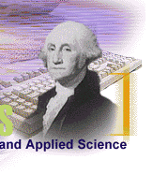
ANNOUNCEMENT FOR THE FINAL EXAMINATION FOR THE DEGREE OF DOCTOR OF ENGINEERING



School of Engineering and Applied Science
Engineering Management and Systems Engineering Department (EMSE)

Name: Michael Wacey
GWID: g34761456

Education:
- Bachelor’s Degree: Computer Science, Washington University in St. Louis

- Master’s Degree: Computer Science, Drexel University

Praxis:

- Date of Final Examination: November 24, 2025

- Time of Final Examination: 4:00 PM ET

- Field of Studies: Artificial Intelligence

- Admission to doctoral program: January 4, 2024

- Entered research: Mnemosyne: Using Large Language Models to Convert Documents to Knowledge Graphs to Check for Completeness and Consistency

- Current Email Address: michael.wacey@gwu.edu

- Director of The Candidate’s Research: Dr. Mohamed Elbasheer

- Examining Committee: John M. Fossaceca, Mohamed Elbasheer, Jonathan Ng

- Chairperson of the Examination Committee: John M. Fossaceca

